**Pizza Sales**

Pizza Sales

**SQL Query Problem Statement** 2

**PowerBi** 7

Data Cleaning 7

KPI’s Requirement 7

# **SQL Query Problem Statement**

1. Find Total Revenue

SELECT SUM(total_price) as "Total Revenue"

FROM pizza_sales



1. Average order Value

SELECT SUM(total_price)/COUNT(DISTINCT order_id) as Avg_Order_Value

FROM pizza_sales



1. Total Pizza Sold

Select SUM(quantity) As Total_pizza_Sold

From pizza_sales



1. Total Orders

SELECT COUNT(DISTINCT order_id) AS TotalOrders

FROM pizza_sales



1. Average Pizzas Per Order

-Average number of pizzas sold per order, calculated by dividing the total number of pizzas sold by the total number of orders.

SELECT CAST(CAST(SUM(quantity) AS DECIMAL(10,2))/

CAST(COUNT(DISTINCT order_id) AS DECIMAL(10,2)) AS DECIMAL(10,2))

AS AVG_Pizzas_per_order

FROM pizza_sales



Charts Requirement

1. Daily Trend for Total Orders:

SELECT DATENAME(DW,order_date) as Order_day, COUNT(DISTINCT order_id) AS Total_orders

FROM pizza_sales

GROUP BY DATENAME(DW,order_date)

1. Hourly Trend for Total Orders

SELECT DATENAME(MONTH, order_date) AS MONTH_NAME, COUNT(DISTINCT order_id) AS Total_orders

FROM pizza_sales

GROUP BY DATENAME(MONTH, order_date)

ORDER BY Total_orders DESC

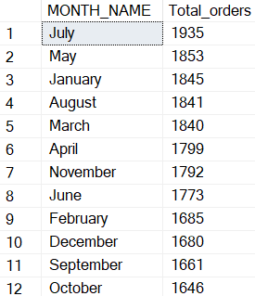

1. Percentage of Sales by Pizza Category

SELECT pizza_category,SUM(total_price) as Total_Sales, SUM(total_price)*100 / (SELECT SUM(total_price) from pizza_sales) AS Percentage_Sales

FROM pizza_sales

Group by pizza_category

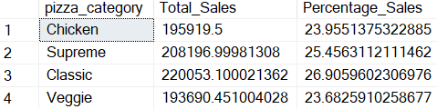

3a) Percentage of Sales by Pizza Category By January only

SELECT pizza_category,SUM(total_price) as Total_Sales, SUM(total_price)*100 / (SELECT SUM(total_price) from pizza_sales WHERE MONTH(order_date)=1) AS Percentage_Sales

FROM pizza_sales

WHERE MONTH(order_date)=1

Group by pizza_category

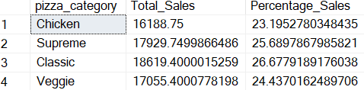

1. Percentages of Sales By Pizza Size

SELECT DISTINCT pizza_size,SUM(total_price) AS TotalSales, CAST(SUM(total_price)*100/(SELECT SUM(total_price) from pizza_sales)AS decimal(10,2)) AS PercentagesofSales

FROM pizza_sales

WHERE DATEPART(quarter, order_date)=1

GROUP BY pizza_size

ORDER BY PercentagesofSales DESC

1. Total Pizzas Sold By Pizza Category  
   SELECT pizza_category, SUM(quantity) AS Quantity

FROM pizza_sales

GROUP BY pizza_category

ORDER BY SUM(quantity) DESC

1. Top 5 Best Sellers by Total Pizzas Sold

SELECT TOP 5 pizza_name, SUM(total_price) AS TotalRevenue

FROM pizza_sales

GROUP BY pizza_name

ORDER BY SUM(total_price) DESC

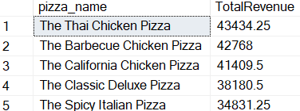

1. Bottom 5 Worst Sellers by Total Pizzas Sold

SELECT TOP 5 pizza_name, SUM(total_price) AS TotalRevenue

FROM pizza_sales

GROUP BY pizza_name

ORDER BY SUM(total_price) ASC

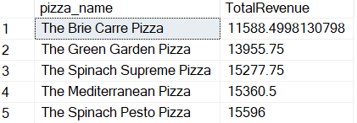

# **PowerBi**

DESKTOP-D79QBA4\SQLEXPRESS

Pizza DB

## Data Cleaning

Transform Data and replace values to change the name of the different size of pizza.

## KPI’s Requirement

1. Total Revenue
2. Average Order Value
3. Total Pizza Sold
4. Total Orders
5. Average Pizzas Per Order

Home

Total Revenue, Average Order Value, Total Pizza Sold, Total Order, Average Pizza per Order, Daily Trend for Total Order, Monthly Trend for Total Order, % of Sales by Pizza Category, % of Sales by Pizza size and Total Pizza sold bu Pizza Category.

Best/Worst Sellers

Top 5 Pizza by Revenue, Top 5 Pizzas by Quantity, Top 5 Pizzas by Total Orders, Bottom 5 Pizzas by Revenue, Bottom 5 Pizzas by Quantity, and Bottom 5 Pizzas by Total Orders.

